**Dissertation**

**KF7029 MSc Computer Science and Digital Technologies Project**

**Student Name:**

**Supervisor Name:**

**Second Marker Name:**

**Dissertation Title**

.

Declaration

I declare the following:

1. that the material contained in this dissertation is the result of my own work and that due acknowledgement has been given in the bibliography and references to **ALL** sources be they printed, electronic or personal.
2. the Word Count of this Dissertation is ...................................
3. that unless this dissertation has been confirmed as confidential, I agree to an entire electronic copy or sections of the dissertation to being placed on the eLearning Portal (Blackboard), if deemed appropriate, to allow future students the opportunity to see examples of past dissertations. I understand that if displayed on the eLearning Portal it would be made available for no longer than five years and that students would be able to print off copies or download.
4. I agree to my dissertation being submitted to a plagiarism detection service, where it will be stored in a database and compared against work submitted from this or any other Department or from other institutions using the service.

In the event of the service detecting a high degree of similarity between content within the service this will be reported back to my supervisor and second marker, who may decide to undertake further investigation that may ultimately lead to disciplinary actions, should instances of plagiarism be detected.

1. I have read the North Umbria University Policy Statement on Ethics in Research and Consultancy and I confirm that ethical issues have been considered, evaluated, and appropriately addressed in this research.

**SIGNED:**

ABSTRACT

A person's cognitive burden is the amount of mental effort required to complete a task. Mental Workload Measurement (MWM) refers to the task of determining one's degree of mental effort. There are several uses for MWM, including avionics, driving, fundamental military or space operations, workplace safety, and the profitability of human resources. The goal of the inquiry was to determine whether. Over a large body of research, the cognitive load is an essential factor in determining human performance. It's still a challenge to develop effective, non-contact methods for assessing cognitive stress in real-world situations. We present two innovative vision-based approaches for estimating cognitive load and testing them on a large-scale dataset gathered in real-world driving situations. Which of three levels of a validated reference task is being performed by the observed person determines cognitive load? 3D convolutional neural networks can accurately estimate the cognitive load in 92 people from video alone, according to our best solution in this three-class challenge. To train and evaluate a neural network, this approach relies on driving data, but it doesn't need any calibration or assumptions about the subject's appearance, activity, head attitude, size, or perspective.

Contents

Declaration 2

ABSTRACT 3

1. INTRODUCTION: 6

1.1. Background 8

1.2. Aims: 9

1.3. Objectives: 9

1.4. Research Approach 10

1.5. Structure of the Report 11

2. LITERATURE SURVEY 11

2.1 Biological Background 11

2.2 Signal Acquisition: 17

2.3 Measuring Brain Activity using CNN 21

2.4 Applications of CNN 25

3. USER FATIGUE DETECTION 26

3.1 Fatigue Detection Technology 26

3.2 Method Based on User State 27

3.3 Method Based on User/Driver Performance 32

4. RESULTS: 34

4.1 Approach 34

4.2 Results and Discussion 38

4.3 Kernel Density Estimation (KDE) Visualization 40

4.4 Conclusion 42

5. BUILDING A CONVOLUTIONAL NEURAL NETWORK 42

Creating the Webcam App 53

References 60

# INTRODUCTION:

The human body's most complex organ is the brain. Many experts have worked hard to figure out how the human mind works. Despite this, there is still a long way to go in the development of a functioning theory. Mental/intellectual responsibility, its wellspring of age, assessment, and so on are becoming more important currently, when innovation has taken control of every aspect of our daily lives, to build applications based on them, and for the advancement of humanity. In a wide range of disciplines, including aviation, driving, fundamental military or space missions, and the well-being of employees, mental responsibility estimation (MWM) has a significant role to play.

Convolutional neural networks have become more popular due to advances in computation. Neural networks were first proposed in the 1950s [1]. Networks might be mapped to XOR gates and many more complex solutions using nonlinear layers. The creation of convolutional neural networks was made possible by advances in neural networks. Image processing methods from the past are included in convolutional neural networks (CNNs). Convolutional kernels are used for image processing in convolutional neural networks. Today's convolutional kernels were created by combining the strength of convolutional kernels with the flexibility of machine learning [2]. However, a significant amount of computation and precision is required to train convolutional neural networks. Modern graphics processing units allowed for the necessary calculation to be performed.

Recently, convolutional neural networks have significantly improved their ability to fit. The typical convolutional neural network now has a more significant number of features to deal with. The more features you add, the more work you will have to implement them. It takes a significant amount of time to determine the network's performance for each new parameter configuration adjustment. Observation and interpretation of the results are necessary for each test to determine its impact on the application. The settings for each neural network application vary significantly due to the large variety of applications.

Convolutional neural networks may be used to identify what kind of animal a picture includes, for as a dog or a cat. Image categorization is the technical term for this process. With 60,000 photos in it, Cifar10 is a well-known dataset for image categorization. This data set includes 50,000 for training and 10,000 for testing purposes. Ten classes are each with 6,000 photos in the dataset [3]. A convolution neural network by Cires and high-performance neural networks for visual object categorization [4] is a well-optimized neural network for Cifar10. This study uses convolutional neural networks (CNNs) to categorize the Cifar10 dataset. A sequence of trials is used to fine-tune parameters. [4] is excellent research [4].

Convolutional neural networks may be optimized by hand; however, this technique may not be the most effective. This study proposes a novel way for optimizing the parameters of convolutional neural networks. It does not need the developer's time or effort to locate the parameters. A genetic algorithm is used to develop a convolutional neural network structure in this thesis. The genetic algorithm is used to improve the accuracy of the convolutional neural network by adjusting several of its parameters. According to the results, the suggested convolutional neural network is 4.77 percent more accurate, with 13.4 percent fewer floating operations than the ref. [4].

According to the results of this current study, convolutional neural networks (CNN) data can be used to decode the psychological responsibility for different kinds of assignments performed by subjects, gaining an understanding of how an individual manages a task and performs under certain planned conditions.

### Background

Clients and frameworks may benefit greatly from the Convolution Neural Network (CNN) and the Brain-Computer Interface (BCI) innovations. To complete the partnership, there are no external devices or muscles involved. BCI data analysis is completed by isolating the most important provisions and putting them into a modeling framework. Such processing techniques, however, may come with a heavy computing burden, making them unsuitable for some tasks (e.g., web-based preparation). By combining highlight extraction and characterization into a single pipeline, neural organizing approaches take on another perspective. Deep learning designs are robust and work well even in the presence of a lot of noise, unlike the AI technique. The preparation step of the neural organization may take a long time, but after the neural organization has been established, the boundaries may be easily applied to fresh information, which can be computationally more efficient and more suited to challenges (e.g., real-time learning of unlabeled CNN information).

We still have a lot of work to do in the field of Brain-Computer Interface. If a precise and online method of grouping intellectual mental load information can be developed to employ CNN signals as an interface between programs and the user's brain, a basis for their utilization may be built.

As a first step toward this goal, we put together a trial arrangement to sort out the responsibilities presented to each subject after they complete a specific errand, as well as to understand the hidden significance of different provisions for the characterization of responsibility using different machines learning algorithms.

### Aims:

Our study's objective is to promote intellectual burden assessment calculations that work effectively in the on-road driving scenario when the PC vision-based identification job is challenging and the opportunity to make a choice that assures the safety of the driver is restricted. Assistive innovation, for example, future advanced driver assistance frameworks (ADAS) and semi-autonomous cars that use driver states in increasing the exchange of control options, might benefit from a robust evaluation of cognitive load levels.

### Objectives:

Using Convolutional Neural Networks (CNN), this study aims to assess an individual's workload and weariness while they are engaged in a separate job. The research study's aims include.

When it comes to facial recognition, convolutional neural networks (CNN) are used. It's a complex network that's ready to do a certain job in a specific way. Using Alex Net's prepared CNN model, the motion learning for face recognition has been accomplished.

Extrapolation: Extrapolation is a method, but it is also an art. It is critical to do thorough research and analysis before deciding to include a new feature in the model.

There are many ways to recognize faces in photos, but one of the simplest is using a convolutional neural network (CNN). A preliminary dataset is required, though.

Face Frontalization: This step takes us from the user's initial head picture in an arbitrary position to the aligned, formalized eye region image.

Studies of eye fatigue in 3D TVs, psychological states of individuals, and the identification of driver drowsiness by eye status monitoring are all using the Eye Lid AAM categorization of open and closed eyes.

Use convolutional neural networks (CNNs), particularly for pupil centers in remote eye-tracking systems, to achieve high-performance object localization. Regression-based, fully convolutional, and deconvolutional network architectures are all examined and contrasted for the problem at hand.

### Research Approach

Innovative Approach: We propose two methods for identifying the differentiating indications in ocular development features to avoid cognitive fatigue. As far as public-approval information [1]-driven methodologies go, the utilization of eye development to forecast psychological burden stands out.

Open-Source Software Development: The absence of a reliable open tool for identifying psychological stress in the primitive video of a person's face is a key issue in the study of intellectual strain

### Structure of the Report

To help the reader, we'll go through the report's layout here.

Research into how technology may be used to monitor brain activity was briefly discussed in Chapter 2 of this book. Application of neural networks using convolutional layers The third half of the chapter is devoted to surveys and testing technologies. The weariness of the user was briefly explored using various approaches and techniques. The project was concluded using these strategies. The experiment employing Convolutional Neural Networks was addressed in the 4th chapter.

At the end of the chapter, References of the research included.

# LITERATURE SURVEY

### Biological Background

#### Human Brain

When it comes to our bodies, there is no more incredible marvel than the human brain. There are approximately 100 billion neurons in a normal human brain connected by axons and neurons. Soma, axon, and dendrites make up a neuron's structure. 103 to 105 synapses allow neurons to benefit from each other's synapses. Axonal transmission of electrical pulses from the stimulus aids in regulating physical developments, sensations, and the synchronization of many areas of the body.

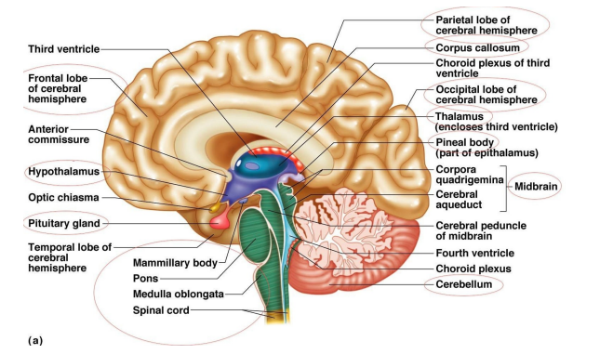

Human brain parts (according to position)

There are three major parts of the brain that make up the forebrain:

• The tectum and tegmentum of the midbrain

Three parts of our brain make up the hindbrain: cerebellum, pons, and medulla.

There are several parts of the human brain (as indicated by capacities). The human brain serves as a hub for both abstract thought and concrete action and the control of the body's other willful and unruly obligatory actions. Various parts of the brain can do so. Since each person's talents are different, the cerebrum may be separated into discrete parts for specialized activities. Two main categories are available:

In mammals, the cerebrum or cortex is the most significant part of the brain, and it is found only in the cerebrum. Thought and action take place at this location.

It is known as the "little brain," and the cerebellum is divided into two hemispheres. Control and coordination of movement, posture, and equilibrium are all a part of its purview. Folds in the cerebellum also increase surface area and neuron density, allowing for more significant neurons in the region.

The limbic system, also known as the "emotional brain," is located deep within the cerebrum and regulates emotions. An essential part of this system is the amygdala and hippocampus; the hypothalamus is also involved.

Breathing, blood pressure, and heartbeat are controlled by the brain stem, which is located beneath the limbic system. The midbrain, pons, and medulla make up the brain stem.

Humans can easily surpass any machine in specific jobs. Image categorization is a good illustration of this. This includes detecting whether a picture has a cat or a dog, for example. Humans can do this easily; computers cannot hard-code it, making it more complicated and time-consuming as more categories are added to classifications. The concept was born to use a computer to mimic the workings of the human brain. Neural networks have been used to describe this approach.

They can now do more complex tasks because of recent advances in neural networks. The ImageNet competition and Google's Go algorithm are two examples of this. One thousand picture categorization categories are used in the ImageNet competition. Every year since 2012, a neural network has won the ImageNet competition. As a result of ImageNet, many new designs for convolutional neural networks have emerged. Neural networks are used in Google's AlphaGo Go programprogram to defeat the world's top players in the game. In contrast to chess, where a computer can calculate every reasonable conclusion, this game is unusual because it has an infinite number of alternative outcomes. These examples highlight how neural networks may be employed in various situations

#### Brain Activity Pattern

Many neurons make up the cerebrum, and every time a person moves, an electric potential is generated and sent via the axons of those neurons. Because different parts of the brain are linked to different functions, the electrical signals generated from neuronal activity vary widely in terms of their frequency, abundance, form, and location. Considering their recurrence, sufficiency, form, and location, these brain waves are arranged in a certain way.

a) Alpha Wave

b) Beta Wave

c) Delta Wave

d) Gamma Wave

e) MU Wave

f) Theta Wave

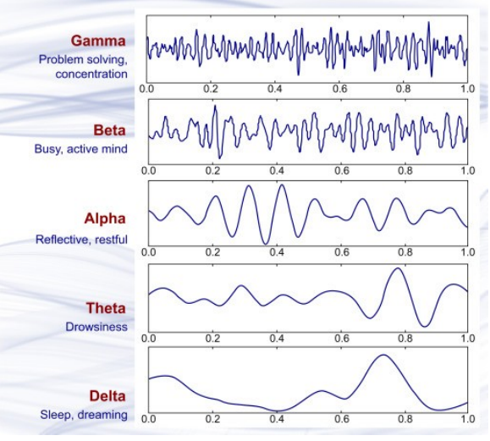

* It is also important to note that the frequency range of the Alpha Waves is from 7.5 Hz to 12 Hz. They are linked to folks who are in alert states, where they are loose and silent.
* In the focal area of the cerebrum and the front side of the brain, Beta Waves originate with a recurrence range of 13-30 Hz. Deep contemplation and a high degree of focus are common characteristics of these people.
* Theta Waves - have a recurrence range of 3.5 to 7.5 Hz and originate in the skull's focal, worldly, and parietal portions. It is common for them to be related to deduction, pressure, and a severe mental state.
* Gamma Waves - their recurrence frequency is more than 30 cycles per second. They are linked to motor skills, multitasking, and being aware that you are doing many things at once.
* This kind of wave is called MU Waves, and it has a repeating rate of 9 Hz to 11% in the head's engine cortex. When there is movement or development, they are linked to the action of the engine.
* In terms of frequency, delta waves span from 0.5 to 3.5 Hz in frequency. Relaxation and a severe lethargic mental state are connected.

#### Cognitive Load

Effort expended in working memory is referred to as cognitive load in cognitive psychology. Individuals' ability to deal with facts differs from one another. People who do not like the way the info is organized or presented may have difficulty accessing it. The mental burden shows how successfully the administrator has drawn in intellectual resources, which is a theoretical development. When assessing intellectual curiosity, neurophysiological estimates are superior to both behavior and abstract measurements. Neurophysiological estimates of psychological responsibility on the internet might become crucial as monitoring procedures and, more fundamentally, support tools for the customer throughout employability activities. Indeed, it should be possible to regulate the client's errand interest so that he or she can keep up with the optimal levels of mental responsibility throughout the task period.

### Signal Acquisition:

When a strategy is interpreted into it, the goal is expressed as a quantitative indicator. This indication is critical to the proper functioning of any BCI. Sign security solutions aim to discern whether the signs are obtained intrusively or noninvasively by the client. Every method of getting a sign is linked to an underlying spatial and ephemeral sign objective. Choosing the best technique for a given circumstance depends on balancing the plausibility of obtaining the sign in the working environment and the aim required for an accurate interpretation—intrusive Methods.

The early work of Hubel and Wiesel [56] reawakened interest in convolutional neural associations (CNN) for Lecun et al. [55]. By using unprocessed images rather than hand-coded characteristics, CNN has a significant edge over other news organizations. With practice, CNNs may become used to the game strategy of the best representation. This tiered network contains a variety of trading layers, convolutional layers, and sub-examining layers for when in question. The convolutional and sub-testing layers used by CNN and the associations available for use are subject to modification. The number of generated maps and the size of the individual parts determine how parametrized a convolutional layer will be—a diagram of the look affirmation system suggested. The design and testing phases of the system are divided into two parts, as is customary. This phase uses a picture of a face and its eyes as its input data. Afterwards, the eyes are made to spin evenly by performing a spatial normalization. All new images will be generated using a Gaussian scattering algorithm to increase the database's size for the foreseeable future. After that, the between-eyes distance is used to remove any establishing information and maintain the enunciation's specific components, and the process is repeated. A down sampling approach has been completed to get the various elements in various images in a comparable area. Afterwards, the picture undergoes a power normalization process. The Convolutional Network is built using the normalized images. The planning process yields many weights that accomplish the best possible outcome with the ready data. The readiness process uses spatial normalizing, management, down sampling, and power normalization in the testing phase. One of the six crucial enunciations tends to be the yield of the formula. Size. One assistance is created by moving the bit over the large area of the information image. Getting the optimal loads associated with the component is an essential aspect of the CNN learning approach. The learning may employ an overall tendency technique, like the one presented in. Using sub-assessment layers, position invariance may be assembled by reducing the assistance size. Each pixel in the more critical standard variation is considered in the new reduced aid. Most limit pooling and ordinary pooling are the main types of sub-inspecting layers. If you pool the best pixels from each neighborhood, the new assistant will preserve the best pixel value; however, if you pool more pixels, the new pixel value will be an average of the neighbors. Convolutional associations are used to distinguish faces, and a standard-based calculation determines the subject's mood [57]. The subject is free to look affirmation is to be updated using a standard-based calculation. Using principles like the distance between eyes and mouth, the length of an even line region in the mouth, and the segment length of even line in brows, this framework may be applied to almost any face shape or size. Researchers conducted tests on a small sample of 10 people and found that 97.6 per cent of the time, they could distinguish between those who seemed happy and those who did not. "It's recent" The creators did not include the time it took to plan the project and the time it took to get internet confirmation. In [58], a video-based affirmation framework is presented. Three-dimensional convolutional neural networks, or 3D-CNNs, were urged to use five reformist edges as 3D wellsprings of data. "It is true.

Everyone desires to share a positive outlook with the world. A wide range of devices, including mechanical innovation, drugs, automated flying vehicles, and lie markers, may be found in the collection. Data shows a range of emotions, including anger, anxiety, happiness, pity, and sarcasm. Using Convolutional Neural Networks, Ninad and their social event study recently presented facial inclination affirmation [1]. A portion of vector extraction has been used to create the underlying fragment for murdering the institution from the images. They analyzed the 10,000 photos and 154 appearances that had been placed aside for management purposes. Using an expressional model with 24 characteristics, the findings reveal that the accuracy is around 96%. Cohn Kaneda, Caltech, CMU, and NIST all utilized more than 750K photos in their study [1], which they offer here.

Liliana's second experiment was a current effort to recognize the occurrence of face Action Units (AUs) as a subset of FACS that represents human tendency [2]. A regularization approach dubbed "dropout" was utilized to demonstrate that CNN was very persuasive in reducing overfitting. In their preliminary, they employed the Cohn Kaneda (CK+) dataset. Then, a usual accuracy rate of 92,81 per cent is achieved. Dataset images were needed in eight inclination classes. Besides that, we will share Zeynab's article on her and their joint research. Facial expressions are explained in terms of five essential facial attitudes in this paper's CNN approach. Despite the model's uniqueness, it performed well on both datasets with a small number of neural layers [3]. Pooling and dropout layers have been added to the model's beaten and convolutional layers. The results of their analysis suggested that they could discern a wide range of facial feelings from the dataset.

Over a few years, FER has been tested using two or three different methods. Primarily focusing on the highlights of the face image, traditional pioneering approaches next assemble an emotional response from the solidified qualities. This is evident in large new learning frameworks that combine all the methods into one single pragmatic cycle. One of the newer evaluations (41 and 42) coupled the critical learning-based systems with the various ebb and flowed FER methodologies [17,18]. In the following sections, the frameworks used in prominent FER approaches are quickly shown. Automated FER is a difficult job in the AI area, particularly in the AI subdomain. The improvement of the FER problem employs a variety of conventional AI approaches (e.g., K-nearest neighbor, neural association). Before employing Fisher's immediate discriminants (FLD) and KNN to eliminate characteristics that eventually seek emotion, Xiao-Xu and Wei's FER approach introduced wavelet energy incorporate (WEF) into the face image. Zhao et al. [44] also employed KNN for FER representation, but they used PCA and non-negative grid factorization (NMF) for feature extraction. Finally, Feng et al. [45] employed an instant programming method (LP) to synchronize feelings by combining twofold model (LBP) histograms from several small sections of the picture. From a 2D discriminant area, Zhi and Ruan obtained face segment vectors. Lee et al. [47] applied a contourlet change (CT) for 2D incorporation extraction from the picture using a boosting algorithm. Chang and Huang [48] employed twisted reason work (RBF) neural connections to obtain information about people' dispositions by combining facial affirmation with FER.

The support vector machine (SVM) was utilized in various ways to combine the feelings of separate segments. According to Shih and colleagues [49], the DWT with the 2D-straight discriminant examination (LDA) outperforms the others in this category. Shan et al. [50] conducted a comprehensive evaluation of face portrayals relying on genuine components and LBPs using various SVMs. [51] Javid et al. analyzed an appearance-based extraction method termed the neighborhood directional model (LDP). Alshami et al. [35] recently examined using SVM two-part descriptors known as the facial achievements descriptor and the point of convergence of gravity descriptors. SVM and a few other processes (e.g., KNN, LDA) were considered part of Liew and Yairi [17]'s comprehensive investigation into feature removal utilizing several systems, including Gabor, Haar, and LBP. Unmistakable depiction strategies including key backslide, LDA, KNN, request and backslide trees, guiltless Bayes and SVM were explored by Joseph and Geetha [52] on their recommended facial math-based segment extraction as part of their most recent evaluation [53]. One of the most important implications of the previously discussed conventional techniques is that they only serve as forward-looking views for FER, as normal component extraction processes specifically extract the parts of forward-looking and profile views.

For BCIs, invasive acquisition of cerebrum signals is developed mainly by electrophysiologic accounts from terminals implanted neurosurgical either inside or over the mind's surface."

### Measuring Brain Activity using CNN

It is possible to represent human twists of events using HAR procedures. Information sources for HAR include signals from accounts [1] or multichannel time-series, such as IMU assessments. Multichannel time-series data is used in this investigation. Specific applications need the collection, analysis, and investigation of human activity signal series. Examples include generating brilliant, helpful inventions or making enhancements to businesses where manual labor is still the primary mode of operation. HAR is an orderly job. Hand-created highlights are separated from the split successions in a sliding-window technique in a standard HAR pipeline, and a classifier is prepared for assigning activity labels to the successions. There are many ways to classify human activities, but this categorization is very difficult because of the wide range of inter-and intra-class variation. Somehow, people manage to complete comparison tasks unexpectedly. When choosing crates, for example, workers may alter their method of picking a crate depending on the size of the container, its surface, or their level of weariness.

CNN's have been successfully used to address HAR difficulties related to motion recognition and activities of daily living. Consolidating element extraction and arrangement in a start-to-finish manner using CNNs is advantageous compared to traditional approaches [2–5,9,10]. The element extractors are non-straight changes, and they are derived directly from crude information that is more discriminative in terms of human activity classes than previously available. Moreover, it is impossible to calculate the proportions of relevant, precisely constructed highlights. Using a few channels and a pool of tasks, convolutional neural networks (CNNs) understand the non-direct and ephemeral relationships between more basic and complicated human processes [2,9]. Convolution and pooling tasks are accomplished along with the time hub in each of these architectures. In addition, the sensors' channels are separated amongst the convolutions, resulting in a small receptive field. As a result, the same limits are applied to all sensors and surrounding signals, which are likely to be interconnected. [2,4,9] These short-lived relationships are invariant to contortions and worldly interpretations. Time-series data may be gleaned from a variety of sensors on wearable tech. These devices may be found in different human body regions, including the hands, feet, head, and abdomen. To keep up with changes in human development, it is typical to focus on the body-worn sensors' estimates. In this study, a new CNN was proposed for use in a request selection circumstance. Sensors that are worn on the body are analyzed individually with this technology. As a result of this investigation, a request-picking scenario was examined using traditional procedures based on factual components, which were presented in. The work in [11] focused on a private dataset; thus, we add further obligations to remember an evaluation of the suggested engineering for two benchmark datasets for HAR. In addition, we evaluated several configurations of the profound engineering presented in and of the preparation approach, including the number of layers, the use of max-pooling tasks, different learning rates, and the structure of the profound models.

Classifier difficulties are dealt with using calculations, such as Machine Learning, Neural Network, Support Vector Machine, Deep Learning, and Naive Bayes. To create a histogram utilizing any of the face component depictions, we will use the Backing Vector Machine (SVM). SVM creates a hyperplane to divide up the three-dimensional space. Obtaining an ideal division occurs when the hyperplane and the preparation information for any class are at their closest points.

Sajid et al. used the facial acknowledgement innovation (FERET) dataset to examine the influence of facial unevenness as a marker of age [28]. According to their findings, the unevenness on the right side of the face is unmatched by that on the left. The contemporary look of the face is still a vital issue when it comes to facial discovery.

Face images may be analyzed using a variety of methods to extract mathematical and surface properties, including local parallel examples LBP [29], facial activity units [30], nearby directional examples LDA [31], and the Gabor wavelet algorithm. For some time now, researchers have turned to profound learning as a very fruitful and effective methodology due to results obtained with its designs that consider the programmed extraction of components and arrangement, such as CNN and RNN, which are examples of convolutional and repetitive neural organizations, respectively. Experts are attempting to provide deep brain organization structures that generate extremely pleasing consequences in this location.

A creative design CNN with Sparse Batch standardization-standardization SBP was presented by Cai et al. [33] in 2018 for the disappearing or explosion slope problem. To avoid over-fitting, the dropout is applied between three related layers, with the first two convolution layers being used sequentially, followed by max-pooling and SBP. Li et al. [34] provide a creative CNN technique for the face impediment problem, in which data is first arranged in a VGGNet organization and then the CNN process with the consideration component ACNN is used. [34] The RO, RAFDB, and Affect Net databases were used to create and evaluate this technology.

Deepak Jain et al. [35] have developed a progressive calculation for learning. There are four convolution layers in each of the two remaining squares. This model is trained on the JAFFE and CK+ datasets after a pre-handling step that clipping and distributes the photo's force.

A spatial-transient designer based on a combination of CNN and LSTM is proposed by Kim et al. [36], investigating the differences in appearance during emotional states. CNN begins by learning the spatial qualities of an image in all its possible states, followed by an LSTM that safeguards the complete arrangement of these spatial attributes. Additionally, Yu et al. [37] are some of the contributors to this effort. Another concept proposed is known as Spatio-Temporal Architecture. A technique known as Spatio-Temporal Convolutional with Nested LSTM (STC-NLSTM) uses three deep learning sub-organizations, such as 3DCNN, to extract spatiotemporal provisions, followed by transient TLSTM to preserve the globally powerful, and finally, convolutional C-LSTM to provide staggering highlights.

### Applications of CNN

A convolutional neural organization is used to decompose facial acknowledgement into the accompanying key portions.

* To identify and focus on each face in the picture, independent of other aspects like light, point, presence and so on, it is necessary to identify and focus on each face.
* Comparing every piece of information acquired to the data set to find a face with a name based on the comparisons.
* Convolutional neural networks may also be used for the study of archives.

This is important for handwriting research, but it also has a significant impact on the recognition process. A computer must compare a person's composition to its vast database of information at the rate of roughly 1,000,000 commands per second. The error rate is believed to have been reduced to at least 0.4 per cent at the individual level using CNNs and more up-to-date models and computations, although it has yet to be widely tested. In addition, CNN's may be used for more complex applications, such as regular history collections. There are a variety of organisms that play an essential role in documenting historical events, such as the appearance of diverse species, development, natural disasters, organic attacks, and environmental changes.

This knowledge may help fight environmental change, especially by gaining insight into why we observe such unusual shifts and how we might strive to mitigate the damage specific scenarios may have. To provide viewers with a more accurate depiction of the current situation, the foggy condition has been included in CNN feeds. This is how CNNs now operate: each inquiry has both a legitimate and an unsubstantiated motivation. The fact is that there are a thousand shades of grey in this world. Its unique shade of grey characterizes every aspect of life..

# USER FATIGUE DETECTION

Because of the lack of rapid methods, fatigue estimate is a significant problem, with most proportions of exhaustion instead of tiredness itself. Any self-report technique has its own set of problems, including those related to the effect of interest and inspiring influences [2]. Street safety is at risk because of these characteristics of tiredness estimate. It has been a decade since many experts have been working to improve the checking frameworks using different methods. Physiological miracles like thought waves, pulse, beat rate, and breath are the most accurate means of discovering new things. The drivers will be inconvenienced by these processes, which include connecting a few cathodes to them.

### Fatigue Detection Technology

Due to boring driving circumstances or other natural reasons, a gradual decline in sharpness may be seen as the most prevalent means of falling off at the worst possible moment. This lessened preparedness induces a state of cushioned awareness, followed by rest. The primary concern of a fatigue detection system is how to distinguish drowsiness accurately and early in the early stages. It is possible to categorize the many methods for detecting driver fatigue into three distinct categories.

[2]

* Strategies that are dependent on the driver's momentum and the driver's current state.
* Strategies depend on the driver's momentum and the driver's current state.
* Strategies based on the combination of the driver's momentum rate and the driver's current state..

### Method Based on User State

Eye alterations and developments have been the topic of several articles on identifying weakness influences and determining how the driver's current situation affects his or her driving ability. A driver's gaze, flickering rate, and actual eye conclusion are all analyzed as part of this process. Additionally, other predictions for determining driver physiological status have been made as well.

Mouth shape, head position, and EEG signal are examples. Below is a detailed breakdown.

If a driver's visual behavior can be predicted, it is possible to predict whether they will be drowsy, cautious, or observant of their surroundings.

Separated appearance-based approaches (based on appearance alone) and dynamic IR (Infrared)-based strategies may be used to categorize face and eye recognition and tracking research. In the past, identifying eyes relied on how different they looked from the rest of the face. They generally consist of two stages: locating the face to disentangle the eye locations and then discovering the eyes via the eyes. The neural organization, head parts, free segments, and skin shading-based approaches have all been used to solve the face finding problem. To locate and follow the driver's gaze, Eriksson and Papanikolaou Poulos have developed a framework that they offer in their paper. To locate a face in a low-contrast image, they use an evenness-based approach. If the eyes are open or closed, it is determined by how the format coordinates. For the location of driver fatigue, Singh and Papani kolo Poulos [8] present a vision-based approach that does not rely on noodling. While driving, the driver's eyes are tracked by a shading camera that focuses directly on his or her face to identify little rests.

To find a face in the data, the framework makes use of skin-shading data. Immediately after skin-like coloring of the pixels, mass preparation is used to determine the precise positioning of the face. To find and track the location of the understudy, they use dim scale model coordination; they also use a similar example recognition process to determine if the eye is open or closed. Whenever the eyes are closed for a long duration (5-6 seconds), the system concludes that the person is dozing asleep and provides a warning. The Framework for Processing Video [9] was used by Wahlstrom, Masoud, and Papani kolo Poulos to accomplish their goal. To begin the verification process, the software uses shading inspection to locate the driver's lips. As a result, the driver's skin tone may be analyzed, and a face district can be created. Lips and eyes are the most central apertures at this location. The product identifies the haziest pixels in the eyes as the understudies when they are found. It uses the overall locations of the eyes and understudies to make statements about the look going. To assess human driver preparedness, Smith, Shah, and Lobo have devised a framework. Global movement and shading data are used to monitor a person's head accurately and face provisions. For example, the framework recognizes eye/mouth obstruction, detects flashing eyes, and recovers the 3D appearance of the eyes. Furthermore, the framework might be followed by obstacles due to eye flickering and eye conclusion, massive mouth growth, and impediment due to pivot.

This video-based approach, known as PERCLOS (Percent Eye Closure), provides a reliable indicator of a driver's sharpness. Slow eyelid closures, rather than squints, account for PERCLOS, which measures the time the driver's eyelids are closed 80 per cent or more of the time [13]. There are two images of the driver that the technique takes. Infrared illumination at 850 nm generates an identifiable glowing of the driver's students in the main image (the red-eye impact). Using infrared light with a wavelength of 950 nm, a picture of drab undergrads is created in the following image. Except for the picture's understudies' brightness, these two images are indistinguishable. As a framework, the framework is compared to a variety of different execution measurements. Comparatively, two electroencephalographic (EEG) computations, a head tracker device, and two wearable eye-flicker displays [13] exhibit the most evident link with driving test performance on PERCLOS. A video-based methodology for measuring PERCLOS [14] has been developed by the Carnegie Mellon Research Institute's Elegance and various analysts.

Also, Liu, Xu, and Fujimura describe an ongoing eye recognition technique that operates under factor and realistic illumination situations [15]. Combining IR light imaging with appearance-based item recognition techniques allows the approach to track eyes even when the understudies are not exceptionally bright due to large exterior light impedances. A help vector machine (SVM) and mean shift following combine the appearance model with eye detection and follow-up. For the face component, Gu, Ji, and Zhu provide a working technique [16]. The dynamic IR sensor, for starters, is used to make clear distinctions between students in low-light environments. It is at this point that the well-trained understudies are used to anticipating changes in head position. In addition, face growth is expected to be smooth enough that a Kalman channel may be used to track a specific facial component. Removed neighborhood charts are used to capture the geographic connection between identified items. Finally, a chart-based unshakable quality spread is presented to deal with the obstacle problem and test the following consequences.

A few seconds before the actual event, eye-share data seems to carry information regarding small rest occasions [18]. The understudy's width exhibits a progressively fluctuating example connected with no modification of the eye-stare facilitates around 10 seconds before the mini rest occurs. The eye-stare arrangements float till the eyes are closed as the understudy gets closer to the little resting place. After the second eye conclusion event, the eye's behavior, which was halted by accident, is very intriguing. Following the accident, the understudy's breadth grew significantly about the eye-rapid stare's movements. It is a common occurrence for a person who has been shaken out of his routine by a disaster to try at regaining his bearings. However, this strategy is challenging to use in real-world driving situations since it is poorly constructed to provide the learner breadth. When a motorist is driving, usually either chatting or relaxing, the degree to which his or her mouth opens is rather distinctive. Using Fisher classifier, Chu et al. remove mouth shape and position, then use mouth district's math character as component worth, and put these provisions together to make up an eigenvector as the contribution of a three-level Bp organization, and then, at that point, the yield is obtained among three distinct soul states [19]. [19] With the head position sensor framework MINDS (Micro-Nod Detection System) introduced by ASCI, the conductivity estimates of the head are used to differentiate tiny rest events occurring in connection to head gestures. [20] The progress of the driver's head is being tracked. When the driver's head position is matched to the sign, the product indication detects drowsy driving-related head movement. In any event, there are also instances of little pauses without any distinct head gestures. Two approaches have been deemed viable for use in the medical field. Face LAB, a tool used by Seeing Machines, and PERCLOS are two examples. Driver visual behavior, including tiredness and drowsiness, may be assessed using Face LAB [21]. Compared to most other proportions of eye conclusion and appear course, this one is one of a kind. Face LAB uses a pair of dormant camcorders. Innovative computer software is used to match some aspects from the left and right images to determine the 3D location of each object in real-time. The precise 3D position of the head is determined using a least-squares advancement based on the arrangement of coordinated components. In addition, the face LAB software measures the eyes' images to determine eye stare estimate data. Iris locations and eye-stare vectors are combined to determine the trajectory of each eye's gaze, which is then shown on a screen. Eyelids are also screened to determine eye openings and flicker rates, which may be used to determine how quickly someone's eyes move. LAB's face LAB system has been tested in a simulated driving situation. It has the advantage of adjusting to low light circumstances, head development, and following gaze bearing when the driver is wearing sunglasses. The electroencephalographic (EEG) calculation, a physiological sluggishness metric, has been used to determine drowsiness. Some studies have used EEG to confirm the presence of fatigue while other measures are being evaluated rather than as a weariness identification measure [22, 23]. [22, 23 Researchers found that an EEG calculation for discriminating between exhaustion and laziness under recreated settings had a strong correlation with an EEG calculation for distinguishing between fatigue and laziness [24]. Because of the difficulty in obtaining accounts in everyday driving situations, EEG as an on-street languor identification device is considered a very absurd option for detecting weakness [2]. According to one group of analysts, the research center’s head posture, eye look, and pupillary shift have all been used to measure driver preparedness. [18]. There is no one metric that can accurately and reliably assess driver fatigue, according to these tests. If a robust method for identifying depletion is to be developed, a multiparametric approach should be applied. To assess driver caution, Ji and Yang [25] suggest a continuous model PC vision framework. With a remote video CCD camera, an extraordinarily planned equipment framework for continuous picture procurement and control of the illuminator, an alert framework, and various PC vision calculations, a driver's level of carefulness may be constantly observed while also being non-rudely observed. In visual practices, the eyelids, face orientation, and appearance development are included (student development). The data from a single source is less vulnerable and ambiguous when there are several visible signals.

### Method Based on User/Driver Performance

Most studies on driver performance have focused on route following or a combination of path following and distance tracking. Using a street takeoff warning and intercession paradigm, [26] and [27] analyze driver state assessment. Framework ID is used to create a model and constantly renew its borders while driving. It uses the horizontal vehicle position as the information and regulates the wheel position as the yield. Driver weariness may be detected by adjusting the vehicle's transfer speed or even the model's limits, according to driving test results. The GPS beacon developed by Bertozzi and Broggi is based on mathematical modification and morphological preparation. " [28, 29] The framework can detect street lines on the level and ordered streets in low-light settings.

Wijesoma, Kodogoda, and Balasuriya used two-dimensional radar detection and extended Kalman filtering to quickly locate and track street inspections. 8589 When it comes to creating a framework that can handle massive variations in street parameters, such as illumination quality, these techniques face a severe challenge. In a meeting at the Australian National University, many street signs were used to identify the car's location in the route under changing street circumstances [31]. The methods are use in commercial vehicles. It is designed to alert the driver when the vehicle unexpectedly crosses a route marker or a roadway edge, allowing them to avoid a collision.

As an afterthought, the vibration of the seat alerts the driver to the fact that the route has been encroached upon. When it comes to driver tiredness locator devices, most driver execution percentages seem positive. Instead of focusing on the effects of changes in the driver's mood that are crucial for street well-being, these strategies indirectly attempt to uncover signs of driver weariness. When a motorist takes a few seconds to nod off on a straight stretch of road, it is referred to as a "mini rest," and it is a problem. It would be impossible to detect these events in a system based just on path position. C. Approaches The Driver's Condition, and Performance Research has shown that methods that combine driver condition and driving performance work on tiredness recognition reasonableness and reliability. Driver fatigue may be detected by various metrics, including Rimini-Doering, Manstetten, Altmueller, Ladstaetter, and Mahler [22]. To prevent fatigue-related accidents, they employ eye conclusion, route following, and changes in physiological status. An ambitious European Union project, termed "AWAKE (System for Effective Assessment of Driver Vigilance and Warning According to Traffic Risk Estimation)," has been completed recently. A primary goal of this project is to demonstrate the mechanical viability of driver caution watching frameworks and examine the non-technical difficulties that might affect the use of such frameworks.

It uses many indicators of driver condition, such as changes in the way the driver holds the steering wheel and how they use the gas and brake pedals and their overall driving style. The results are compared when these activities are taken in conjunction with computerized route maps, anticollision gadgets, driver look sensors, and odometer readings to evaluate ebb-and-flow traffic danger. The project developed plan guidelines for the assessment of driver watchfulness and warning signals. In the future, these guidelines will have a significant impact on the use of weakness-discovery devices.

# RESULTS:

### Approach

An innovative technique has been employed to identify facial expressions. We must first identify the face and the eye to do this. Dlib's package has a pre-trained frontal face detector that uses a modified Histogram of Oriented Gradients and Linear SVM to classify faces. Pupils are not included in this version of the 68 Landmark model. As a result, a 70-point facial landmarks dataset was used to train Dlib's Facial Landmark Detector on the pupil region of the eye.

#### Dlib’s Facial Landmark Detector:

Vahid Kazemi and Josephine Sullivan developed Dlib's facial landmark detector based on their research. [CITATION Vah14 l 1033] For their training set, they use a collection of regression trees that have been trained on a labelled facial landmarks picture. It is used to compute the area of the facial milestones of 68 (x, y) organizations that match face designs. The figure below shows the results of 68 landmarks. The 70-landmark model was used, however.

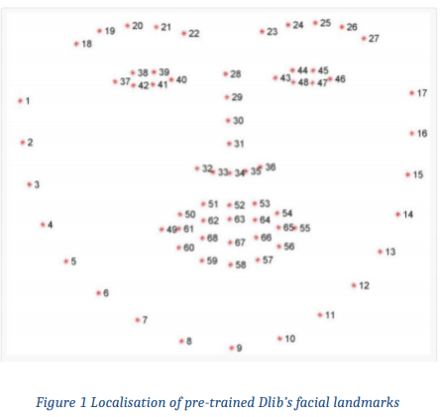

#### ***Eliminate Effect of Lighting***:

Gamma Correction and histogram equalization helped us overcome the slight unpredictability.

A contrast-correction technique in image processing known as histogram equalization employs the picture's histogram. Images with a modest number of power esteem tend to benefit from this method's ability to boost their overall contrast. It is possible to disperse the forces throughout the histogram better, using the whole range of powers. This makes it possible to improve contrast in areas with weak local contrast. Using histogram equalization, the tightly packed intensity values that reduce contrast are efficiently spaced out.

As an example, the nonlinear interaction of Gamma Correction is utilized in video and still picture frameworks to encode and interpret luminance or tristimulus values. As a result, a nonlinear transition between information and characteristics is used to enhance contrast.

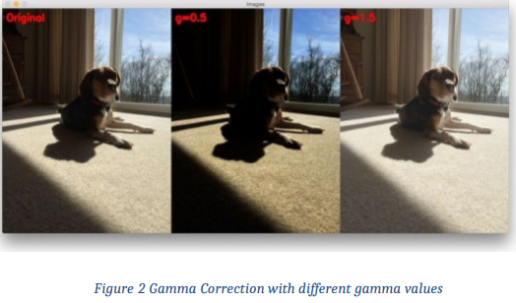

#### ***Aspect ratio of eyes and check status***

To determine whether the eyes are open or closed, the aspect ratio is determined. The eye is open if the Eye Aspect Ratio is greater than the threshold. (Roughly 0.3.).

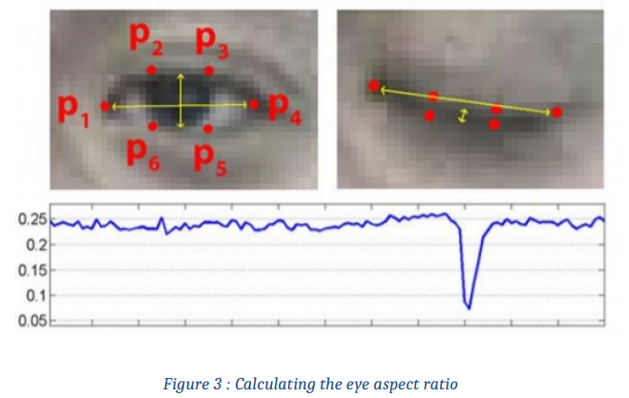

#### Decision on blink and Drowsiness

Between 200 and 300 milliseconds, a blink should be sufficient time for a person to blink. Between 800 and 900 milliseconds, a drowsy blink would occur. To keep track of the history of eye status and assess whether the blink should be natural, we use a finite state machine. Let us assume that the time interval between two frames is 100 milliseconds (varies between computers). Is it valid if the blink is less than a millisecond long? (3 frames). Depending on whom you ask, this might vary. The individual is drowsy if their eyelids stay closed for longer than 900 milliseconds (9 frames)

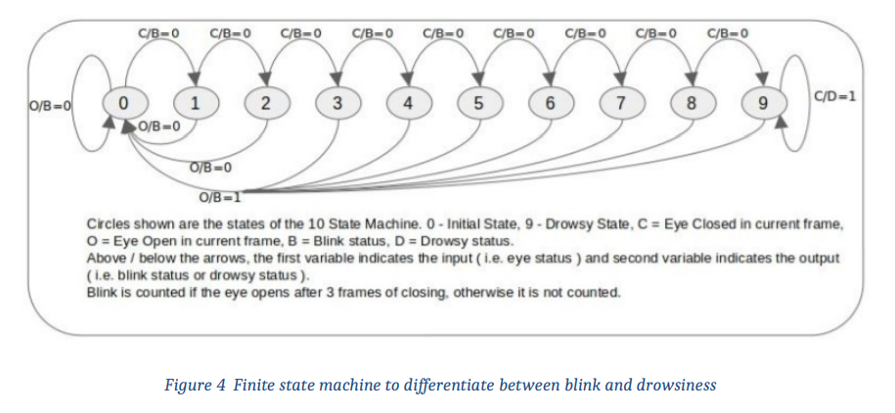

To make our model insensitive to the system's frame rate, we will do the following steps: Determine the frame rate of the processor that we are going to use. Convert blink time and sleepy time into the number of frames based on this frame rate.

### Results and Discussion

Ten randomly chosen training-testing splits were used to evaluate the approach on a dataset of 92 participants in the study. More than 70 people were trained, and just 18 were tested, resulting in an 80/20 split of participation. Cross-validation was not performed on any of the subjects in either the training or testing sets. The 3D-CNN models were trained using a TensorFlow version of stochastic gradient descent using mini-batches of 100 video clips per participant and 80 training epochs. CNN techniques execute two tasks: (1) extract pupil position and blink state, and (2) track changes in these variables across time.

The CNN approach does not explicitly perform one of these steps. A deconvolutional network is used to probe each layer of the network to train the CNN network. Ocular region characteristics are learned in the initial frames by the CNN. Activating the movement of the pupil and eyelids is demonstrated below in the following pictures.

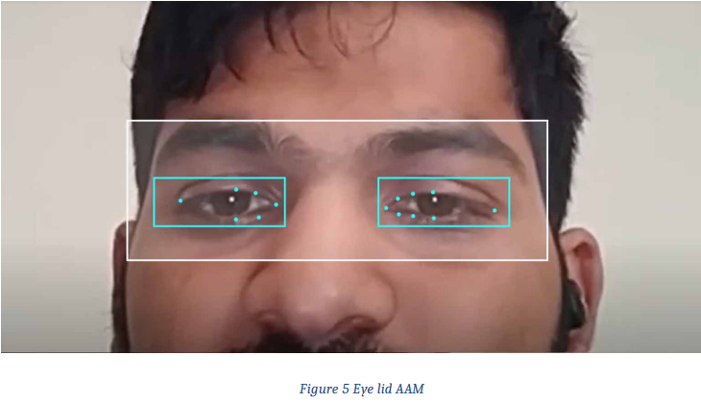

Because of the large dataset and the inherent difficulties of assessing cognitive load as a task, particularly in a real-world scenario, the results for CNN approaches are exemplary. An eye region dynamics measure, captured by visible light and analyzed using modern computer vision algorithms, was shown to be a contender for evaluating general cognitive load. The result for the detection of EEG is given by:

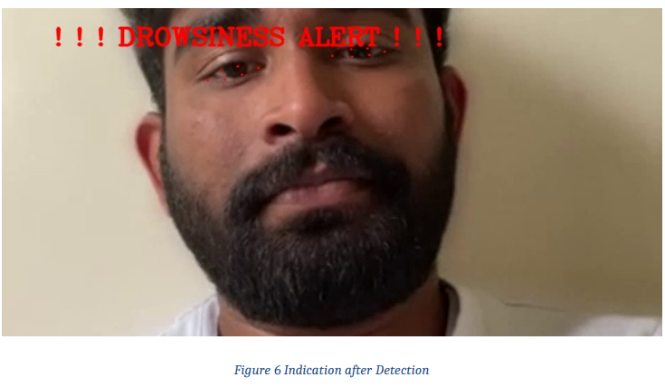

### Kernel Density Estimation (KDE) Visualization

#### Cognitive Load Task

Using the n-back task, participants are presented with a set of single-digit numbers and asked to memorize and repeat them verbally. Alternatively, two different numbers are shown (e.g., 0 back and one back) (2- back). They have shown off (2-back)—every one of these three tiers matters. Accomplishing the project requires an ever-increasing amount of mental energy. Random digits 0-9 are handed out in a 2.25-second gap between each number. Task periods of around 30 seconds were employed in this study's participants, resulting in task durations of approximately 30 seconds in this study's subjects.

#### KDE Demonstration

The probability Density of a constant variable may be shown using the KDE Plot or Kernel Density Estimate. It shows the probability density.

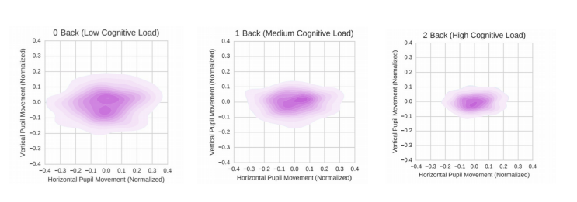

Kernel density estimation (KDE) is used for each cognitive stress level to visualize relative pupil movement. The most used method is the "intraocular distance" (the distance between the predicted landmark locations of the two corners of the eye) to normalize the axes.

#### Pupil Trajectories with HMMS

The pre-processing pipeline's output is used to approximate the pupil's position. Pupil pixel position is normalized using the length of the line segment that connects the two outer corners of the pupil's pupil. The midpoint of the "intraocular" line segment is the origin, the x-axis is parallel to it, and the y-axis is perpendicular to it to determine the eyeball's normalized location. A position of (0,0) is assigned if no prior position is known, or if no previous position is known, the pupil is allocated the last known location.

To describe cognitive load as a set of Hidden Markov Models, each 6-second classification epoch is defined as a sequence of 90 normalized pupil locations (HMMs).

### Conclusion

The job of assessing cerebral stress in the open air is a daunting one. We propose two PC vision-based solutions to this problem. The fundamental strategy employs HMM models. The 3D-CNN model is used in the final technique. According to 90 recognized light video diagrams, both depend on the same eye parts within six seconds. However, the 3D-CNN system operates from the beginning on the unfinished grayscale eye area photo groupings. On a dataset of 92 people, the HMM strategy has a usual accuracy of 77.7 per cent, whereas the 3D-CNN approach has a typical accuracy of 86.1 per cent.

# BUILDING A CONVOLUTIONAL NEURAL NETWORK

**Data Collection**

The primary data sources for our analysis were open eye face data from UMass Amherst and closed eye face data from Nanjing University.

After removing the eyeballs with a simple python script, we were left with slightly over 30,000 photos of cropped eyes. A buffer was applied to each image crop to capture the eye and the surrounding area. Later, this cropping feature will be repurposed for use with the webcam.

|  |
| --- |
| # installations from command line |
|  | # brew install cmake # dlib requirement |
|  | # pip install dlib # face_recognition requirement |
|  | # pip install face_recognition # library for detecting eye location |
|  | # imports: |
|  | from PIL import Image, ImageDraw |
|  | import face_recognition |
|  | import os |
|  | def eye_cropper(folders): |
|  | # Establish count for iterative file saving |
|  | count = 0 |
|  |  |
|  | # For loop going through each image file |
|  | for folder in os.listdir(folders): |
|  | for file in os.listdir(folders + '/' + folder): |
|  |  |
|  | # Using Facial Recognition Library on Image |
|  | image = face_recognition.load_image_file(folders + '/' + folder + '/' + file) |
|  | # create a variable for the facial feature coordinates |
|  | face_landmarks_list = face_recognition.face_landmarks(image) |
|  |  |
|  | # create a placeholder list for the eye coordinates |
|  | eyes = [] |
|  | try: |
|  | eyes.append(face_landmarks_list[0]['left_eye']) |
|  | eyes.append(face_landmarks_list[0]['right_eye']) |
|  | except: |
|  | continue |
|  | # establish the max x and y coordinates of the eye |
|  | for eye in eyes: |
|  | x_max = max([coordinate[0] for coordinate in eye]) |
|  | x_min = min([coordinate[0] for coordinate in eye]) |
|  | y_max = max([coordinate[1] for coordinate in eye]) |
|  | y_min = min([coordinate[1] for coordinate in eye]) |
|  | # establish the range of x and y coordinates |
|  | x_range = x_max - x_min |
|  | y_range = y_max - y_min |
|  |  |
|  | # to make sure the full eye is captured, |
|  | # calculate the coordinates of a square that has 50% |
|  | # cushion added to the axis with a larger range |
|  | if x_range > y_range: |
|  | right = round(.5*x_range) + x_max |
|  | left = x_min - round(.5*x_range) |
|  | bottom = round(((right-left) - y_range))/2 + y_max |
|  | top = y_min - round(((right-left) - y_range))/2 |
|  | else: |
|  | bottom = round(.5*y_range) + y_max |
|  | top = y_min - round(.5*y_range) |
|  | right = round(((bottom-top) - x_range))/2 + x_max |
|  | left = x_min - round(((bottom-top) - x_range))/2 |
|  |  |
|  | #crop original image using the cushioned coordinates |
|  | im = Image.open(folders + '/' + folder + '/' + file) |
|  | im = im.crop((left, top, right, bottom)) |
|  |  |
|  | # resize image for input into our model |
|  | im = im.resize((80,80)) |
|  |  |
|  | # save file to output folder |
|  | im.save('yourfolderforcroppedeyes') |
|  |  |
|  | # increase count for iterative file saving |
|  | count += 1 |
|  | # print count every 200 photos to monitor progress |
|  | if count % 200 == 0: |
|  | print(count) |
|  |  |
|  | # Call function to crop full-face eye images |
|  | eye_cropper('yourfullfaceimagefolder') |

If you don't want individuals blinking or 200 photographs of Bill Clinton to train your model, you'll need to manually clean this dataset. As an example of the data we utilised to build the model, consider the following:

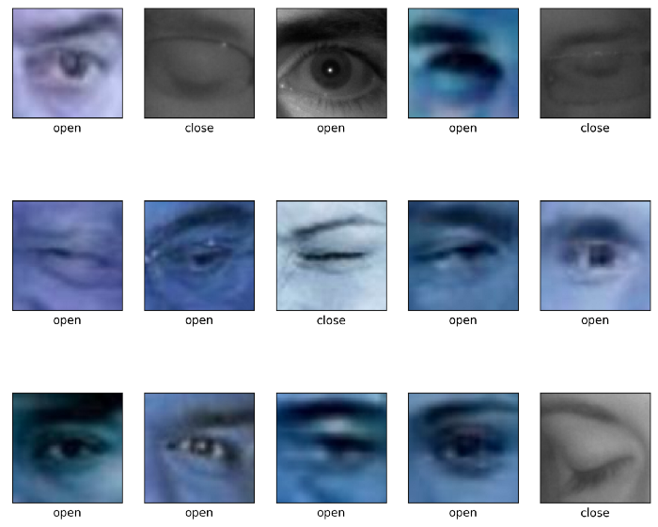

**Creating a Convolutional Neural Network**

**Decide on a Metric**

Our most significant parameter will be the ability to forecast the positive class (a sleeping driver) rather than the negative class (an awake driver) (sensitivity). The fewer sleeping drivers the program incorrectly guesses are awake, the greater the recall (false negatives).

It is just an issue that our negative class has a significant lead over our positive class. Using the F1 or Precision-Recall AUC scores are preferable since they consider the number of times we incorrectly believe a driver is sleeping, but they are awake (precision). Because if we do not, our model will constantly assume that we are sleeping and so useless. When dealing with unbalanced data sets, we did not utilize image augmentation. It is not something I used, but Jason Brownlee does a fantastic job describing how you can hear.

**Prepare Image Data**

The next step is to import the images and preprocess them for the model.

Imports needed for this section:

**import cv2  
import** **tensorflow** **as** **tf**  
**from** **tensorflow** **import** keras  
**from** **sklearn.model_selection** **import** train_test_split  
**from** **tensorflow.keras.wrappers.scikit_learn** **import** KerasClassifier  
**from** **keras.models** **import** Sequential  
**from** **keras.layers** **import** Dense,Flatten,Conv2D,MaxPooling2D,Dropout

Using our last photographs, import them and resize them to fit together. We reduced the dimensions to 80x80 pixels for this project. The OS library is used to perform this basic import function.:

|  |
| --- |
| def load_images_from_folder(folder, eyes = 0): |
|  | count = 0 |
|  | error_count = 0 |
|  | images = [] |
|  | for filename in os.listdir(folder): |
|  | try: |
|  | img = cv2.imread(os.path.join(folder,filename)) |
|  | img = cv2.resize(img, (80,80)) ## Resizing the images |
|  | ## for eyes if it is 0: open, 1: close |
|  | images.append([img, eyes]) |
|  | except: |
|  | error_count += 1 |
|  | print('ErrorCount = ' + str(error_count)) |
|  | continue |
|  |  |
|  | count += 1 |
|  | if count % 500 == 0: |
|  | print('Succesful Image Import Count = ' + str(count)) |
|  |  |
|  | return images |
|  |  |
|  | folder="../data/train/new_open_eyes" |
|  | open_eyes = load_images_from_folder(folder, 0) |
|  |  |
|  | folder="../data/train/New_Closed_Eyes" |
|  | closed_eyes = load_images_from_folder(folder, 1) |
|  | eyes = close_eyes + open_eyes |

Set up variables with the independent X being the images, and dependent y being the corresponding labels (1 for closed eye, 0 for open eye):

X = []   
y = []   
**for** features, label **in** eyes:   
X.append(features)  
y.append(label)

Convert the image to an array so it can enter the model. Also, scale the data by dividing by 255.

X = np.array(X).reshape(-1, 80, 80, 3)  
y = np.array(y)  
X = X/255.0

Split the data into a training set and a validation set using scikit learn’s train_test_split. **Important:**makesure to stratify y because we have imbalanced classes.

X_train, X_test, y_train, y_test = train_test_split(X, y, stratify = y)

**Creating a Model Architecture**

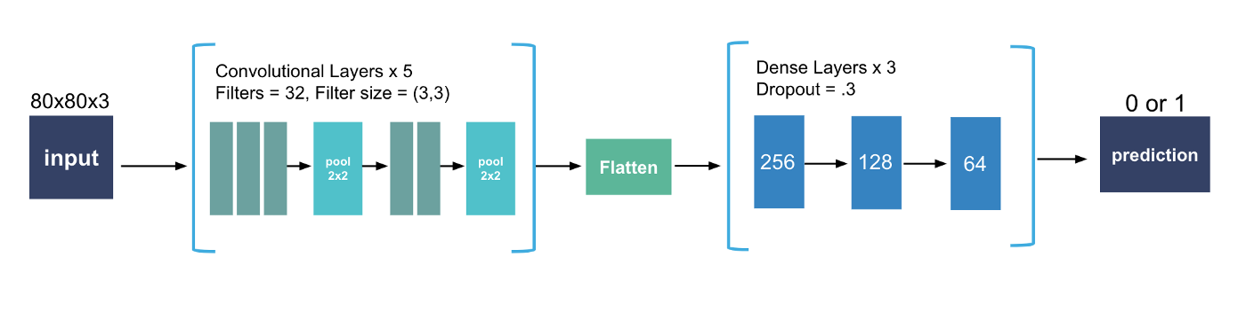

**Convolutional Layers:**

Instead of creating the whole image, subsets of pixels are generated, which expedites the model generation process. However, if you use a lot of filters on the original photographs, the model will be able to learn more complex correlations with fewer resources. For this job, I used a whopping 32 distinct filters. While one convolutional layer is a decent place to start, it is common to use two or more. The best setup for me was two 3x3s pooled together, followed by three 3x3s pooled together. The smaller the filter, the more common it is on CNN. A double 3x3 layer is almost equivalent to a 5x5 layer except that it is faster and usually results in better ratings, as Arnault Chazareix describes in this great piece. Pooling isn't always necessary or even preferred. Test your model both ways if you can.

**Flatten**

Make sure to flatten the image array so it can enter the dense layers.

**Dense Layers**

Your model will take longer to train if it has a lot of thick layers. The intricacy of the connections acquired by the network will rise as the number of neurons in these layers grows. Generally, convolutional layers are designed to eliminate the need for a dense layer scheme that is too deep. We employed three layers of neurons that were activated by relu at a decreasing pace for our model (256, 128, 64). A 30 percent dropout was also employed between layers.

**Output Layer**

Finally, because this a binary classification problem, make sure to use the sigmoid activation for your outer layer.

**Compile Model**

In model.compile(), you’ll want to set the metric to PR AUC (tf.keras.metrics.AUC (curve = 'PR') in tensorflow) or recall (tf.keras.metrics.recall in tensorflow). Set loss equal to binary_crossentropy because this a binary classification model and a good optimizer is generally adam.

**Fitting the Model**

Set your **batch size** generally as high as possible, but don’t blow up your machine in the process! I ran a gridsearch on Google Colab’s 32 GB TPU and it ran 1000+ batches with ease. When in doubt, try 32 batches and increase if it doesn’t overload your memory. In terms of **epochs**, there were diminishing returns after 20 epochs, so I wouldn’t go much higher than that for this specific CNN.

Here’s the full setup with Tensorflow Keras:

|  |
| --- |
| # Instantiate the model |
|  | model = Sequential() |
|  |  |
|  | # Adding first three convolutional layers |
|  | model.add(Conv2D( |
|  | filters = 32, # number of filters |
|  | kernel_size = (3,3), # height/width of filter |
|  | activation = 'relu', # activation function |
|  | input_shape = (80,80,3) # shape of input (image) |
|  | )) |
|  | model.add(Conv2D( |
|  | filters = 32, # number of filters |
|  | kernel_size = (3,3), # height/width of filter |
|  | activation = 'relu' # activation function |
|  | )) |
|  | model.add(Conv2D( |
|  | filters = 32, # number of filters |
|  | kernel_size = (3,3), # height/width of filter |
|  | activation = 'relu' # activation function |
|  | )) |
|  |  |
|  | # Adding pooling after convolutional layers |
|  | model.add(MaxPooling2D(pool_size = (2,2))) # Dimensions of the region that you are pooling |
|  |  |
|  | # Adding second set of convolutional layers |
|  | model.add(Conv2D( |
|  | filters = 32, # number of filters |
|  | kernel_size = (3,3), # height/width of filter |
|  | activation = 'relu' # activation function |
|  | )) |
|  | model.add(Conv2D( |
|  | filters = 32, # number of filters |
|  | kernel_size = (3,3), # height/width of filter |
|  | activation = 'relu' # activation function |
|  | )) |
|  |  |
|  | # Add last pooling layer. |
|  | model.add(MaxPooling2D(pool_size=(2,2))) |
|  |  |
|  | model.add(Flatten()) |
|  |  |
|  | # Adding first dense layer with 256 nodes |
|  | model.add(Dense(256, activation='relu')) |
|  |  |
|  | # Adding a dropout layer to avoid overfitting |
|  | model.add(Dropout(0.3)) |
|  |  |
|  | model.add(Dense(128, activation='relu')) |
|  | model.add(Dropout(0.3)) |
|  |  |
|  | model.add(Dense(64, activation='relu')) |
|  | model.add(Dropout(0.3)) |
|  |  |
|  | # adding output layer |
|  | model.add(Dense(1, activation = 'sigmoid')) |
|  |  |
|  | # compiling the model |
|  | model.compile(loss='binary_crossentropy', |
|  | optimizer='adam', |
|  | metrics=[tf.keras.metrics.AUC(curve = 'PR')]) |
|  |  |
|  | # fitting the model |
|  | model.fit(X_train, |
|  | y_train, |
|  | batch_size=800, |
|  | validation_data=(X_test, y_test), |
|  | epochs=24) |
|  |  |
|  | # evaluate the model |
|  | model.evaluate(X_test, y_test, verbose=1) |

**Final Precision-Recall Area Under the Curve Score:**

0.981033

Let me know if you can better this!

# ****Creating the Webcam App****

Once you have a model you’re happy with, save it using model.save('yourmodelname.h5'). Make sure to run the production model **without the validation data** when saving it. This will cause problems down the road when importing it.

**Installations and Imports:**

These are Mac optimized, although it’s possible to use this same script on Windows as well. For troubleshooting windows dlib.

# installations needed for webcam application  
# pip install opencv-python #   
# if you want to play a sound for the alert:  
# pip install -U PyObjC  
# pip install playsound# imports for webcam application  
import cv2  
from playsound import playsound  
# import model saved above  
eye_model = keras.models.load_model(‘best_model.h5’)

**Using OpenCV to Access the Webcam**

Use cv2.VideoCapture(0) to start the webcam capture. If you’d like to make text locations based on relative frame size rather than absolute coordinates make sure to save the width and height of the webcam using cap.get(cv2.CAP_PROP_FRAME_WIDTH). You can also view frames per second. The full list of capture properties for OpenCV can be found .

cap = cv2.VideoCapture(0)  
w = cap.get(cv2.CAP_PROP_FRAME_WIDTH)  
h = cap.get(cv2.CAP_PROP_FRAME_HEIGHT)  
print(cap.get(cv2.CAP_PROP_FPS))if not cap.isOpened():  
 raise IOError(‘Cannot open webcam’)

**Capturing the Frames with OpenCV and Cropping Them**

Make sure to set a counter if you plan on counting eyes closed by frame. A while True: loop will keep the camera on until you’re finished with the script. In that while loop, use the ret, frame = cap.read() format to capture the frame of the webcam video. Lastly, call the function on the frame. It should return a cropped eye from the frame, if it can’t find an eye in the frame, the function will return None which can’t be divided by 255 and will skip to the next frame.

counter = 0# create a while loop that runs while webcam is in use  
while True: # capture frames being outputted by webcam ret, frame = cap.read() # function called on the frame  
 image_for_prediction = eye_cropper(frame)  
 try:  
 image_for_prediction = image_for_prediction/255.0  
 except:  
 continue

**Running the Frame through the Model**

We can then run the image through the model and get a prediction. If the prediction is closer to 0, then we display “Open” on the screen. Otherwise (i.e. it’s closer to 1), we display “Closed”. Notice that the counter is reset to 0 if the model detects open eyes and counter is increased by 1 if the eyes are closed. We can display some basic text to indicate whether the eyes are closed or open using cv2.putText().

prediction = eye_model.predict(image_for_prediction)if prediction < 0.5:  
 counter = 0  
 status = ‘Open’ cv2.putText(frame, status, (round(w/2)-80,70),  
cv2.FONT_HERSHEY_SIMPLEX, 2, (0,255,0), 2, cv2.LINE_4)  
 else:  
 counter = counter + 1  
 status = ‘Closed’ cv2.putText(frame, status, (round(w/2)-104,70), cv2.FONT_HERSHEY_SIMPLEX, 2, (0,0,255), 2, cv2.LINE_4)

We also want to **display an alert if there’s 6 frames in a row with closed eyes** (“sleeping”). This can be done using a simple if statement:

if counter > 5:  
cv2.putText(frame, ‘DRIVER SLEEPING’, (round(w/2)-136,round(h) — 146), cv2.FONT_HERSHEY_SIMPLEX, 1, (0,0,255), 2, cv2.LINE_4)  
counter = 5

And lastly, we need to display the frame and provide an exit key for the while loop. The cv2.waitKey(1) determines how long the frame will be shown. The number in parentheses is the amount of milliseconds the frame will be displayed for unless the “k” key is pressed which in this case is 27, or the escape key:

cv2.imshow(‘Drowsiness Detection’, frame)  
k = cv2.waitKey(1)  
if k == 27:  
break

Outside of the loop, release the webcam and close the application:

cap.release()  
cv2.destroyAllWindows()

OverAll code

|  |
| --- |
| import cv2 |
|  | import numpy as np |
|  | from playsound import playsound |
|  | from PIL import Image, ImageDraw |
|  | import face_recognition |
|  | from tensorflow import keras |
|  | eye_model = keras.models.load_model('best_model_2.h5') |
|  |  |
|  | # webcam frame is inputted into function |
|  | def eye_cropper(frame): |
|  |  |
|  | # create a variable for the facial feature coordinates |
|  | facial_features_list = face_recognition.face_landmarks(frame) |
|  |  |
|  | # create a placeholder list for the eye coordinates |
|  | # and append coordinates for eyes to list unless eyes |
|  | # weren't found by facial recognition |
|  | try: |
|  | eye = facial_features_list[0]['left_eye'] |
|  | except: |
|  | try: |
|  | eye = facial_features_list[0]['right_eye'] |
|  | except: |
|  | return |
|  |  |
|  | # establish the max x and y coordinates of the eye |
|  | x_max = max([coordinate[0] for coordinate in eye]) |
|  | x_min = min([coordinate[0] for coordinate in eye]) |
|  | y_max = max([coordinate[1] for coordinate in eye]) |
|  | y_min = min([coordinate[1] for coordinate in eye]) |
|  |  |
|  | # establish the range of x and y coordinates |
|  | x_range = x_max - x_min |
|  | y_range = y_max - y_min |
|  |  |
|  | # in order to make sure the full eye is captured, |
|  | # calculate the coordinates of a square that has a |
|  | # 50% cushion added to the axis with a larger range and |
|  | # then match the smaller range to the cushioned larger range |
|  | if x_range > y_range: |
|  | right = round(.5*x_range) + x_max |
|  | left = x_min - round(.5*x_range) |
|  | bottom = round((((right-left) - y_range))/2) + y_max |
|  | top = y_min - round((((right-left) - y_range))/2) |
|  | else: |
|  | bottom = round(.5*y_range) + y_max |
|  | top = y_min - round(.5*y_range) |
|  | right = round((((bottom-top) - x_range))/2) + x_max |
|  | left = x_min - round((((bottom-top) - x_range))/2) |
|  |  |
|  | # crop the image according to the coordinates determined above |
|  | cropped = frame[top:(bottom + 1), left:(right + 1)] |
|  |  |
|  | # resize the image |
|  | cropped = cv2.resize(cropped, (80,80)) |
|  | image_for_prediction = cropped.reshape(-1, 80, 80, 3) |
|  |  |
|  | return image_for_prediction |
|  |  |
|  | # initiate webcam |
|  | cap = cv2.VideoCapture(0) |
|  | w = cap.get(cv2.CAP_PROP_FRAME_WIDTH) |
|  | h = cap.get(cv2.CAP_PROP_FRAME_HEIGHT) |
|  | if not cap.isOpened(): |
|  | raise IOError('Cannot open webcam') |
|  |  |
|  | # set a counter |
|  | counter = 0 |
|  |  |
|  | # create a while loop that runs while webcam is in use |
|  | while True: |
|  |  |
|  | # capture frames being outputted by webcam |
|  | ret, frame = cap.read() |
|  |  |
|  | # use only every other frame to manage speed and memory usage |
|  | frame_count = 0 |
|  | if frame_count == 0: |
|  | frame_count += 1 |
|  | pass |
|  | else: |
|  | count = 0 |
|  | continue |
|  |  |
|  | # function called on the frame |
|  | image_for_prediction = eye_cropper(frame) |
|  | try: |
|  | image_for_prediction = image_for_prediction/255.0 |
|  | except: |
|  | continue |
|  |  |
|  | # get prediction from model |
|  | prediction = eye_model.predict(image_for_prediction) |
|  |  |
|  | # Based on prediction, display either "Open Eyes" or "Closed Eyes" |
|  | if prediction < 0.5: |
|  | counter = 0 |
|  | status = 'Open' |
|  |  |
|  | cv2.rectangle(frame, (round(w/2) - 110,20), (round(w/2) + 110, 80), (38,38,38), -1) |
|  |  |
|  | cv2.putText(frame, status, (round(w/2)-80,70), cv2.FONT_HERSHEY_SIMPLEX, 2, (0,255,0), 2, cv2.LINE_4) |
|  | x1, y1,w1,h1 = 0,0,175,75 |
|  | ## Draw black backgroun rectangle |
|  | cv2.rectangle(frame, (x1,x1), (x1+w1-20, y1+h1-20), (0,0,0), -1) |
|  | ## Add text |
|  | cv2.putText(frame, 'Active', (x1 +int(w1/10), y1+int(h1/2)), cv2.FONT_HERSHEY_SIMPLEX, 0.7, (0, 255,0),2) |
|  | else: |
|  | counter = counter + 1 |
|  | status = 'Closed' |
|  |  |
|  | cv2.rectangle(frame, (round(w/2) - 110,20), (round(w/2) + 110, 80), (38,38,38), -1) |
|  |  |
|  | cv2.putText(frame, status, (round(w/2)-104,70), cv2.FONT_HERSHEY_SIMPLEX, 2, (0,0,255), 2, cv2.LINE_4) |
|  | x1, y1,w1,h1 = 0,0,175,75 |
|  | ## Draw black backgroun rectangle |
|  | cv2.rectangle(frame, (x1,x1), (x1+w1-20, y1+h1-20), (0,0,0), -1) |
|  | ## Add text |
|  | cv2.putText(frame, 'Active', (x1 +int(w1/10), y1+int(h1/2)), cv2.FONT_HERSHEY_SIMPLEX, 0.7, (0, 255,0),2) |
|  |  |
|  | # if the counter is greater than 3, play and show alert that user is asleep |
|  | if counter > 2: |
|  |  |
|  | ## Draw black background rectangle |
|  | cv2.rectangle(frame, (round(w/2) - 160, round(h) - 200), (round(w/2) + 160, round(h) - 120), (0,0,255), -1) |
|  | cv2.putText(frame, '*****************ALERT**********', (round(w/2)-136,round(h) - 146), cv2.FONT_HERSHEY_SIMPLEX, 1, (0,0,0), 2, cv2.LINE_4) |
|  | cv2.imshow('Drowsiness Detection', frame) |
|  | k = cv2.waitKey(1) |
|  | ## Sound |
|  | playsound('rooster.mov') |
|  | counter = 1 |
|  | continue |
|  |  |
|  | cv2.imshow('Drowsiness Detection', frame) |
|  | k = cv2.waitKey(1) |
|  | if k == 27: |
|  | break |
|  | cap.release() |
|  | cv2.destroyAllWindows() |

OUTPUT:



# References

[1] Loft S., Sanderson P., Neal A., Mooij M., Modeling and predicting mental workload in enroute air traffic control: Critical review and broader implications, in Human Factors, 2007, pp. 376399

[2] A. Williamson, and T. Chamberlain, “Review of on-road driver fatigue monitoring devices”, unpublished

[3] Federico Cirett Gal´an and Carole R. Beal, EEG estimates of engagement and cognitive workload predict math problem-solving outcomes

[4] Jurgen Schmidhuber. Deep learning in neural networks: An overview. Neural networks.

[5] Siyuan Chen and Julien Epps. 2013. Automatic classification of eye activity for cognitive load measurement with emotion interference. Computer methods and programs in biomedicine 110, 2 (2013), 111–124

[6] Lex Fridman, Daniel E. Brown, William Angell, Irman Abdic, Bryan Reimer, and Hae Young Noh. 2016a. Automated Synchronization of Driving Data Using Vibration and Steering Events. Pattern Recognition Letters (2016).

[7] M. Eriksson, and N.P. Papanikotopoulos, “Eye-tracking for detection of driver fatigue,” in Proc .Int. Conf. Intelligent Transportation Systems, Boston, pp. 314-319, 1997

[8] S. Singh, and N.P. Papanikolopoulos, “Monitoring driver fatigue using facial analysis techniques,” in Proc. Int. Conf. Intelligent Transportation Systems, Tokyo, Japan, pp. 314- 318, 1999.

[9] Tal Hassner, Shai Harel, Eran Paz, and Roee Enbar. 2015. Effective face frontalization in unconstrained images. In Proceedings of the IEEE Conference on Computer Vision and Pattern Recognition. 4295–4304.

[10] P. Smith, M. Shah, and N. da Vitoria Lobo, “Monitoring head/eye motion for driver alertness with one camera,” in Proc. 15th Int. Conf. Pattern Recognition, Barcelona, Spain, vol. 4, pp. 636-642, 2000.

[11 ]P. Smith, M. Shah, and N. da Vitoria Lobo, “Determine driver visual attention with one camera,” Intelligent Transportation Systems, vol. 4, pp. 205-218, December 2003.

[12]R. Grace, “Drowsy driver monitor and warning system,” in Proc. Int. Driving Symp. Human Factors in Driver Assessment, Training and Vehicle Design, 2001.

[13] D.F. Dinges, and R. Grace, “PERCLOS: A valid psychophysiological measure of alertness as assessed by psychomotor vigilance,” US Department of Transportation, Federal highway Administration. Publication Number FHWA-MCRT-98-006

[14] R. Grace et al., “A drowsy driver detection system for heavy vehicle,” in Proc. 17th Digital Avionics Systems Conference, Bellevue, USA, vol. 2, pp. I36/1-I36/8, 1998.

[15] X. Liu, F.L. Xu, and K. Fujimura, “Real-time eye detection and tracking for driver observation under various light conditions,” in Proc. Intelligent Vehicle Symp., Versailles, France, pp. 344-351, 2002

[16] H. Gu, Q. Ji, and Z.W. Zhu, “Active facial tracking for fatigue detection,” in Proc. Workshop on Application of Computer Vision, Orlando, pp. 137- 142, 2002

[17] T. Ito, S. Mita, K. Kozuka, T. Nakano, and S. Yamamoto, “Driver blink measurement by the motion picture processing and its application to drowsiness detection,” in Proc. Int. Conf. Intelligent Transportation Systems, Singapore, pp. 168-173, 2003.

[18] A. Heitmann, and R. Guttkuhn, “Technologies for the monitoring and prevention of driver fatigue,” in Proc. Int. Driving Symp. Human Factors in Driver Assessment, Training and Vehicle Design, pp. 81-86, 2001.

[19] J.W. Chu, L.S. Jin, B.L. Tong, S.M. Shi, and R.B. Wang, “A monitoring method of driver fatigue behavior based on machine vision,” in Proc. Intelligent Vehicle Symp., Parma, Italy, pp.351-356, 2004.

[20] P.W. Kithil, R.D. Jones, and M. Jone, “Development of driver alertness detection systems using overhead capacitive sensor array,” SAE Technical Paper Series, 982292, SAE International, 1998.

[21] G. Longhurst, “Understanding driver visual behaviour,” Seeing Machine Pty Limited, 2002.

[22] M. Rimini-Doering, D. Manstetten, T. Altmueller, U. Lasdstaetter, and M. Mahler, “Monitoring driver drowsiness and stress in a driving simulator,” in Proc. Int. Driving Symp. Human Factors in Driver Assessment, Training and Vehicle Design, 2001.

[23] U. Svensson, “Blink behaviour based drowsiness detection,” Linkoping University, Swedish National Road and Transport Research Institute, 2004.

[24] S.K.L. Lal, A. Craig, P. Boord, L. Kirkup, and H. Nguyen, “Development of an algorithm for an EEG-based driver fatigue countermeasure,” Journal of Safety Research, pp. 321- 328, 2003.

[25] V. Hardzeyeu, and F. Klefenz, “On using the Hough. transform for driving assistance applications”, In Proc. Int. Conf. Intelligent Computer Communication and Processing, Cluj-Napoca, pp.28-30, 2008.

[26] Y. Kim, YM. Kim, and M. Hahn, “Detecting Driver Fatigue based on the Driver's Response Pattern and the Front View Environment of an Automobile”, In Proc. Int. Symp. on Universal Communication, pp.237- 240, 2008.

[27] M. Rimini-Doering, D. Manstetten, T. Altmueller, U. Lasdstaetter, and M. Mahler, “Monitoring driver drowsiness and stress in a driving simulator,” in Proc. Int. Driving Symp. Human Factors in Driver Assessment, Training and Vehicle Design, 2001.

[28] C.Y. Chang, “Research on driving safety”, Master Thesis, 2008.

[29] S. Boveris, “Driver fatigue monitoring technologies and future ideas,” in Proc. AWAKE Road Safety Workshop, Balocco, Italy, 2004.

[30] R. Grace, “Drowsy driver monitor and warning system,” in Proc. Int. Driving Symp. Human Factors in Driver Assessment, Training and Vehicle Design, 2001

[31] L. Fletcher, N. Apostoloff, L. petersson, and A. Zelinsky, “Vision in and out of Vehicles,” IEEE Trans. Intelligent Transportation Systems, pp. 12- 17, 2003

[32] S. Boveris, “Driver fatigue monitoring technologies and future ideas,” in Proc. AWAKE Road Safety Workshop, Balocco, Italy, 2004

33] Ying Wang, Bryan Reimer, Jonathan Dobres, and Bruce Mehler. 2014. The sensitivity of different methodologies for characterizing drivers’ gaze concentration under increased cognitive demand. Transportation research part F: traffic psychology and behaviour 26 (2014), 227–237.

1. E. Roberts, “History: The 1940’s to the 1970’s,” https://cs.stanford.edu/people/eroberts/courses /soco/projects/neural-networks/History/history1.html, accessed: 2017-10-03.
2. Y. LeCun, K. Kavukcuoglu, and C. Farabet, “Convolutional networks and applications in vision,” in *Circuits and Systems (ISCAS), Proceedings of 2010 IEEE International Symposium on*. IEEE, 2010, pp. 253–256.
3. A. Krizhevsky, “Learning multiple layers of features from tiny images,” 2009.
4. D. C. Cires¸an, U. Meier, J. Masci, L. M. Gambardella, and J. Schmidhuber, “High-performance neural networks for visual object classification,” *arXiv preprint arXiv:1102.0183*, 2011.
5. “Nodal definition,” http://www.techmaru.com/technology/artificial-neural-networks/neuralnetwork-elements, accessed: 2017-11-14.
6. “The traveling salesman problem,” https://www.cs.nmsu.edu/ dcook/thesis/paper2.html, accessed: 2017-10-03.
7. “The knapsack problem,” http://www.es.ele.tue.nl/education/5MC10/Solutions/knapsack.pdf, accessed: 2017-10-03.
8. I. Sobel, “An isotropic 3 3 image gradient operator,” 02 2014.
9. H. Scharr, “Optimal operators in digital image processing,” Ph.D. dissertation, 2000.
10. Learned-Miller, E., Huang, G. B., RoyChowdhury, A., Li, H., & Hua, G. (2016). Labeled faces in the wild: A survey. In Advances in face detection and facial image analysis (pp. 189-248). Springer, Cham.
11. Brownlee, J. (2016). Image augmentation for deep learning with Keras.
12. Song, F., Tan, X., Liu, X., & Chen, S. (2014). Eyes closeness detection from still images with multi-scale histograms of principal oriented gradients. Pattern Recognition, 47(9), 2825-2838.
13. Wang, J., Chen, Y., Chakraborty, R., & Yu, S. X. (2020). Orthogonal convolutional neural networks. In Proceedings of the IEEE/CVF conference on computer vision and pattern recognition (pp. 11505-11515).
14. Xu, M., Chen, D., & Zhou, G. (2020). Real-Time Face Recognition Based on Dlib. In Innovative Computing (pp. 1451-1459). Springer, Singapore.